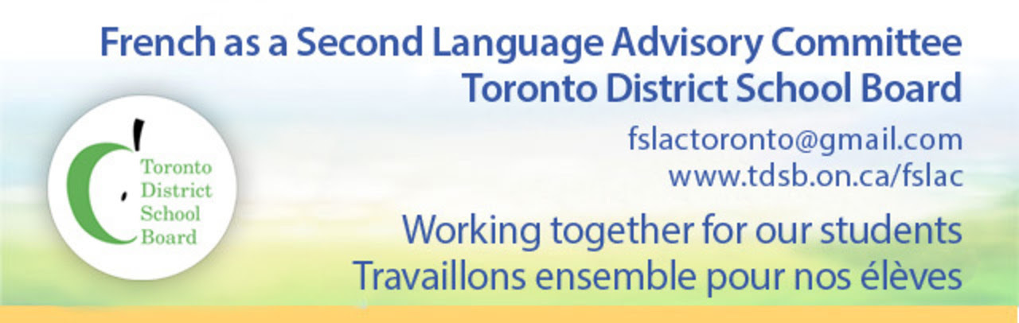

Bonjour!

The French as a Second Language Advisory Committee (FSLAC) is a parent advisory committee of the Toronto District School Board (TDSB). We’re here to support parents and to be your voice on French programs at the Board.

The FSLAC is comprised of parent representatives and alternates elected by each ward council, a parent co-chair elected by FSLAC parent members, a trustee co-chair and designated TDSB staff. We meet every four to six weeks during the school year at the TDSB offices at 5050 Yonge St. You are welcome to attend these meetings, meet other parents of students in French Programs, network, discuss issues and new ideas, voice concerns and hear about initiatives in FSL from staff.

Our webpage www.tdsb.on.ca/fslac has information about French programs and policies as well as links to useful resources for helping children succeed in French.

Please join our e-mail list. Go to www.tdsb.on.ca/fslac and click on the orange button.

Our Mission is to consult with and advise the Board on French as a Second Language matters. As a Board community advisory committee, the FSLAC will contribute to the work of trustees and staff. This partnership of trustees, staff and parents will foster excellence and growth in FSL programs at the Board.

The FSLAC can be reached at: fslactoronto@gmail.com.

